Building Context:
In order to understand the motivation behind regression, let's consider the following simple example. The scatter plot below shows the number of college graduates in the US from the year 2001 to 2012.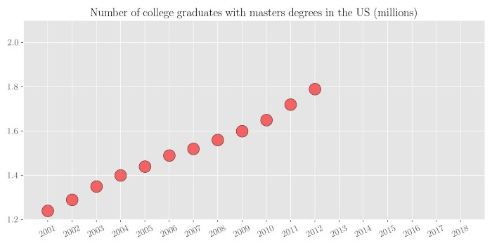
Now based on the available data, what if someone asks you how many college graduates with master's degrees will there be in the year 2018? It can be seen that the number of college graduates with master’s degrees increases almost linearly with the year. So by simple visual analysis, we can get a rough estimate of that number to be between 2.0 to 2.1 million. Let's look at the actual numbers. The graph below plots the same variable from the year 2001 to the year 2018. It can be seen that our predicted number was in the ballpark of the actual value.
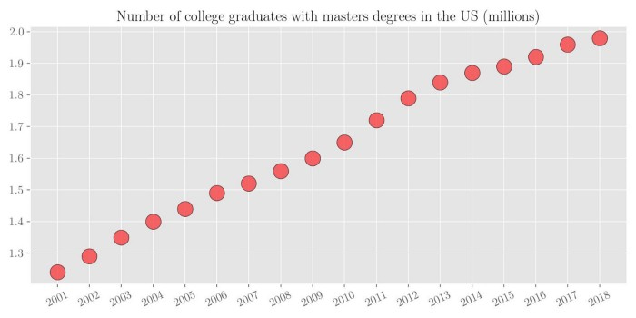
Since it was a simpler problem (fitting a line to data), our mind was easily able to do that. This process of fitting a function to a set of data points is known as regression analysis.

What is Regression Analysis?
. In simpler words, it means fitting a function from a selected family of functions to the sampled data under some error function. Regression analysis is one of the most basic tools in the area of machine learning used for prediction. Using regression you fit a function on the available data and try to predict the outcome for the future or hold-out datapoints. This fitting of function serves two purposes.
- You can estimate missing data within your data range (Interpolation)
- You can estimate future data outside your data range (Extrapolation)
Some real-world examples for regression analysis include predicting the price of a house given house features, predicting the impact of SAT/GRE scores on college admissions, predicting the sales based on input parameters, predicting the weather, etc.
Let's consider the previous example of college graduates.
- Interpolation: Let's assume we have access to somewhat sparse data where we know the number of college graduates every 4 years, as shown in the scatter plot below.
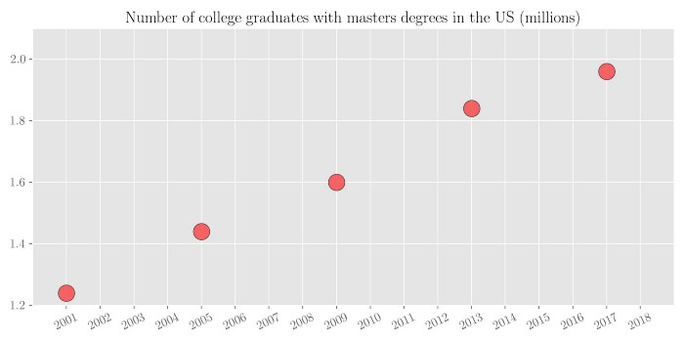

We want to estimate the number of college graduates for all the missing years in between. We can do this by fitting a line to the limited available data points. This process is called interpolation.

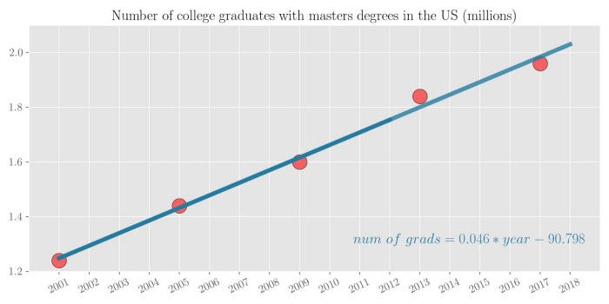

Extrapolation: Let’s assume we have access to limited data from the year 2001 to the year 2012, and we want to predict the number of college graduates from the year 2013 to 2018.
It can be seen that the number of college graduates with master’s degrees increases almost linearly with the year. Hence, it makes sense to fit a line to the dataset. Using the 12 points to fit a line, and then test the prediction of this line on the future 6 points, it can be seen that the prediction is very close.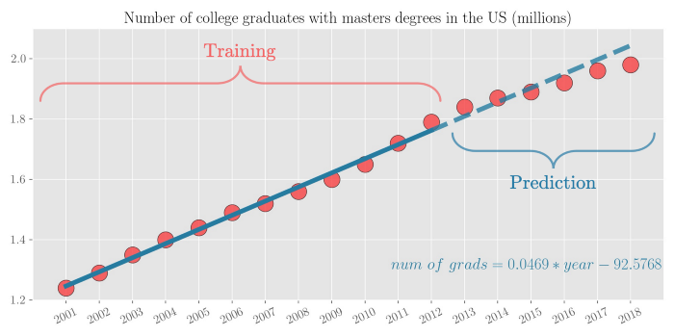

Introduction to Simple Linear Regression

Regression analysis is the process of constructing a mathematical model or function that can be
used to predict or determine one variable by another variable or other variables.
The most elementary regression model is called simple regression or bivariate regression involving
two variables in which one variable is predicted by another variable. In simple regression, the variable
to be predicted is called the dependent variable and is designated as y.

The predictor is called the independent variable, or explanatory variable, and is designated as x. In simple
regression analysis, only a straight-line relationship between two variables is examined.

Linear Regression:
It is a statistical approach to model between a dependent variable and one or more explanatory variables (or independent variables) to come up with a best fit linear line(linear equation, using least squared approach) represented in a most simplified manner as:
Simple linear regression,

y​=β0​+β1​X
X=explanatory variables,
β0​=y-intercept (constant term),
β1​=slope coefficients for the explanatory variable,
We use linear regression to find the relationship between dependent & independent variables to find the best attribute (input variable)to use for model building in solving the regression type problems.
Linear Regression is further classified as
- Simple linear regression: It has only one explanatory variable
- Multiple linear regression: It has more than one explanatory variable. Here multiple correlated dependent variables are predicted, rather than a single scalar variable(dependent variable)
It represents line fitment between multiple inputs and one output, typically:

The Formula for Multiple Linear Regression Is
​yi​=β0​+β1​xi1​+β2​xi2​+…+βp​xip​+ϵ
where, for i=n observations:yi​=dependent variable
xi​=explanatory variables,
β0​=y-intercept (constant term),
βp​=slope coefficients for each explanatory variable,
ϵ=the model’s error term (also known as the residuals)​
In essence, multiple regression is the extension of ordinary least-squares (OLS) regression that involves more than one explanatory variable.
In linear regression, the relationships are modeled using linear predictor functions whose unknown model parameters are estimated from the data.
Linear predictor functions:
In statistics and in machine learning, a linear predictor function is a linear function (linear combination) of a set of coefficients and explanatory variables (independent variables), whose value is used to predict the outcome of a dependent variable.
You will very often come across in our discussion the terms like dependent & independent variables, let’s try to understand the same so that our further discussion more sense going forward

Dependent Variables:
In mathematical /statistical modeling the values of dependent variables depend on the values of independent variables.
The dependent variables represent the output or outcome whose variation is being studied. So in simplified terms
Whenever you try to predict any change in output variable based on any given input variable, this output variable is known as the dependent variable. We can also call them to be a target variable when we analyze them using a linear regression model.

Independent variables:
Also known in a statistical context as regressors, represent inputs or causes, that is, potential reasons for variation. This input variable which is largely mapped in the linear line equation to predict the possible outcome is known as dependent variables.
Example: Simple linear regression line(works for two variable)
y= mX+C
Here y= dependent variable(Target variable) ,
X= Independent (input ) variable.
It is best practice to represent the independent variable to be C=capital letter & dependent variable as a small letter. Though it’s not enforced.

Key Concepts Of Linear Regression:
One needs to understand a few important concepts to make a better sense of the linear regression model which we will study going forward with example. So let’s cover them quickly

Prerequisites:
To start with Linear Regression, you must be aware of a few basic concepts of statistics. i.e.
- Correlation (r): Explains the relationship between two variables, possible values -1 to +1
- Variance (σ2): Measure of spread in your data
- Standard Deviation (σ) : Measure of spread in your data (Square root of Variance)
- Normal distribution: Normal distribution, also known as the Gaussian distribution, is a probability distribution that is symmetric about the mean, showing that data near the mean are more frequent in occurrence than data far from the mean. In graph form, normal distribution will appear as a bell curve.
- Residual (error term): Actual value(Which we have ) Minus Predicted value(Which came using linear regression )
To understand variance, standard deviation, normal distribution, please refer to my article below:https://www.mlanalytics.in/descriptive-statistics-fundamentals-for-data-science-aspirants/
Key Assumptions In the Linear Regression Model:
If we are building a linear regression model we need to take care of the following assumptions, in order to build an effective model that works well.
- The Dependent variable is continuous
- There is a Linear relationship between Dependent Variable and Independent Variable.
- There is no Multicollinearity (no relationship between Independent variables
- Residuals should follow Normal Distribution.
- Residuals should have constant variance: Homoscedasticity
- Residuals should be independently distributed/no autocorrelation
To check the relationship :
Between dependent and independent variable you can,
- Perform Bivariate Analysis
To find whether residuals are normally distributed or not you can,
- Perform Histogram/ Boxplot

To check Homoscedasticity:
- You can Plot Residuals Vs. Predicted values and there should be no pattern in between them when you visualize them using data visualization tools.

Assumptions in Linear Regression
The regression has five key assumptions:
1. Linear relationship: linear regression needs the relationship between the independent and dependent variables to be linear. It is also important to check for outliers since linear regression is sensitive to outlier effects. The linearity assumption can best be tested with scatter plots.
2. Normal Distribution of error terms: If the error terms are non- normally distributed, confidence intervals may become too wide or narrow i.e., unstable. This does not help in estimation of coefficients based on cost function minimization.
3. No auto-correlation: The presence of correlation in error terms drastically reduces model’s accuracy. This usually occurs in time series models where the next instant is dependent on previous instant. The estimated standard errors tend to underestimate the true standard error as the intervals become narrower. This further results in reducing p-value which results incorrect conclusion of an insignificant variable.
4. Heteroscedasticity: The presence of non-constant variance in the error terms results in heteroscedasticity. Generally, non-constant variance arises in presence of outliers or extreme leverage values causing the confidence interval for out of sample prediction to be unrealistically wide or narrow.
5. No or little multi collinearity: Two variables are collinear if both of them have a mutual dependency. Due to this,it becomes a tough task to figure out the true relationship of a predictors with response variable or find out which variable is actually contributing to predict the response variable.
— This causes the standard errors to increase. With large standard errors, the confidence interval becomes wider leading to less precise estimates of coefficients.

Correlation:
Correlation explains how one or more variables are related to each other. These variables can be input data features which have been used to forecast our target variable.
Correlation, statistical technique which determines how one variables moves/changes in relation with the other variable. It gives us the idea about the degree of the relationship of the two variables. It’s a bi-variate analysis measure which describes the association between different variables. In most of the business it’s useful to express one subject in terms of its relationship with others.
For example: No of testing vs no of positive cases in Corona.
1. If two variables are closely correlated, then we can predict one variable from the other.
2. Correlation plays a vital role in locating the important variables on which other variables depend.
3. It’s used as the foundation for various modeling techniques.
4. Proper correlation analysis leads to better understanding of data.
5. Correlation contribute towards the understanding of causal relationship (if any).

Positive Correlation: Two features (variables) can be positively correlated with each other. It means that when the value of one variable increase then the value of the other variable(s) also increases.

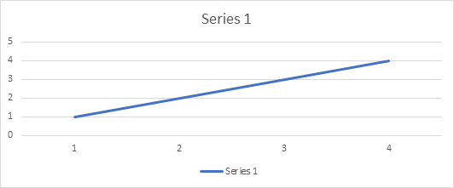
Positive Correlation

Negative Correlation: Two features (variables) can be negatively correlated with each other. It means that when the value of one variable increase then the value of the other variable(s) decreases.

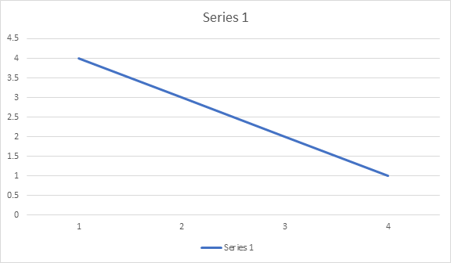
Negative Correlation

No Correlation: Two features (variables) are not correlated with each other. It means that when the value of one variable increase or decrease then the value of the other variable(s) doesn’t increase or decreases.
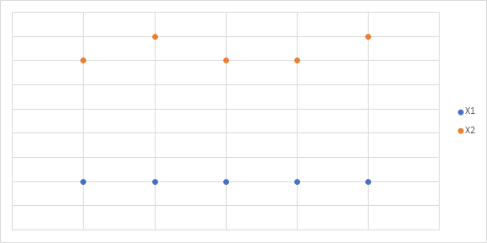
No Correlation

Residuals
A residual is a measure of how far away a point is vertically from the regression line. Simply, it is the error between a predicted value and the observed actual value.

Figure 1 is an example of how to visualize residuals against the line of best fit. The vertical lines are the residuals.

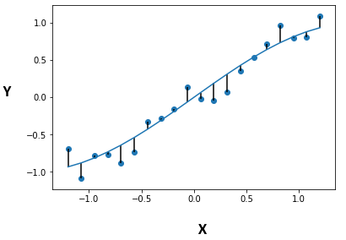
StackOverflow]
Residual Plots
A typical residual plot has the residual values on the Y-axis and the independent variable on the x-axis. Figure 2 below is a good example of how a typical residual plot looks like.

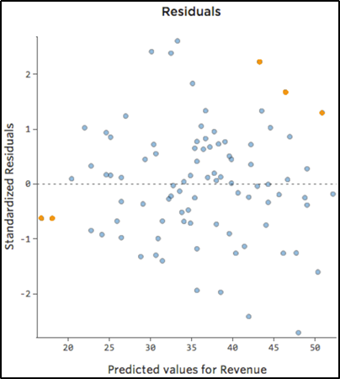
Credit]
Residual Plot Analysis
The most important assumption of a linear regression model is that the errors are independent and normally distributed.
Let’s examine what this assumption means.
Every regression model inherently has some degree of error since you can never predict something 100% accurately. More importantly, randomness and unpredictability are always a part of the regression model. Hence, a regression model can be explained as:

The deterministic part of the model is what we try to capture using the regression model. Ideally, our linear equation model should accurately capture the predictive information. Essentially, what this means is that if we capture all of the predictive information, all that is left behind (residuals) should be completely random & unpredictable i.e stochastic. Hence, we want our residuals to follow a normal distribution. And that is exactly what we look for in a residual plot. So what are the characteristics of a good & bad residual plot?
Characteristics of Good Residual Plots
A few characteristics of a good residual plot are as follows:
- It has a high density of points close to the origin and a low density of points away from the origin
- It is symmetric about the origin
To explain why Fig. 3 is a good residual plot based on the characteristics above, we project all the residuals onto the y-axis. As seen in Figure 3b, we end up with a normally distributed curve; satisfying the assumption of the normality of the residuals.

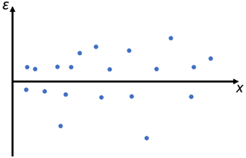

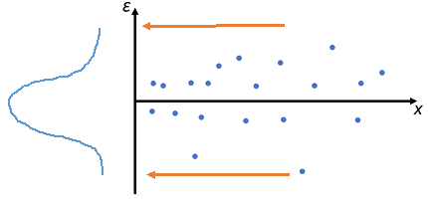
Finally, one other reason this is a good residual plot is, that independent of the value of an independent variable (x-axis), the residual errors are approximately distributed in the same manner. In other words, we do not see any patterns in the value of the residuals as we move along the x-axis.
Hence, this satisfies our earlier assumption that regression model residuals are independent and normally distributed.
Using the characteristics described above, we can see why Figure 4 is a bad residual plot. This plot has high density far away from the origin and low density close to the origin. Also, when we project the residuals on the y-axis, we can see the distribution curve is not normal.

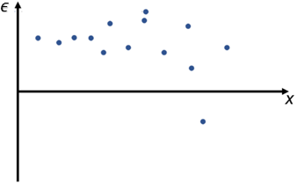

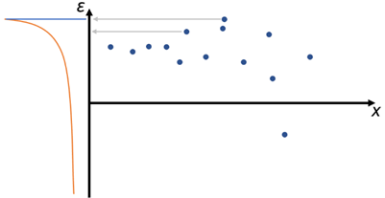
It is important to understand here that these plots signify that we have not completely captured the predictive information of the data in our model, which is why it is “seeping” into our residuals. A good model should always only have random error left after using the predictive information (Think back about Deterministic & Stochastic components)
Summary
To validate your regression models, you must use residual plots to visually confirm the validity of your model. It can be slightly complicated to plot all residual values across all independent variables, in which case you can either generate separate plots or use other validation statistics such as adjusted R² or MAPE scores.

Understanding the Slope and intercept in the linear regression model:
What is a slope?
In a regression context, the slope is very important in the equation because it tells you how much you can expect Y to change as X increases.
It is denoted by m in the formula y = mx+b.
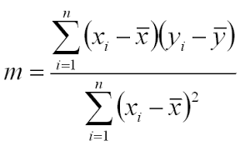
It can also be calculated by the formula,
m = r*(Sy/Sx),
Where r is the correlation co-efficient.
Sy and Sx is the standard deviation of x and y.
And r can be calculated as
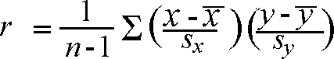
What is Intercept?
The y-intercept is the place where the regression line y = mx + b crosses the y-axis (where x = 0), and is denoted by b.
Formula to calculate the intercept is:
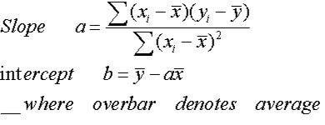
Now,Put this slope and intercept into the formula (y = mx +b) and their you have the description of the best fit line.
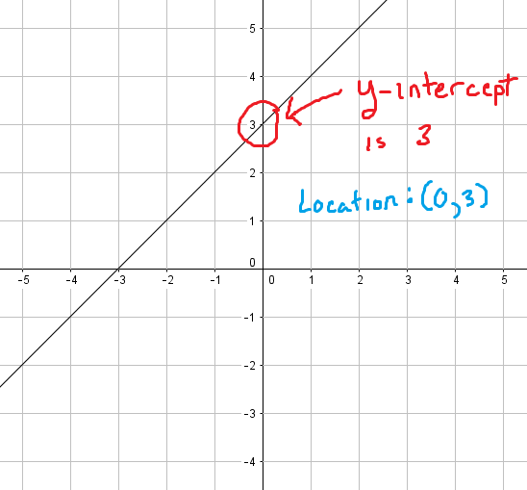
This best fit line will now pass through the data according to the properties of a regression line that is discussed below.Now,What if i tell you there is still room to improve the best fit line?
As you know, we want our model to be the best performing model on unseen data and to do so Stochastic Gradient Descent is used to update the values of slope and intercept,so that we acheive very low cost function of the model.

How does a linear Regression Work?
The whole idea of the linear Regression is to find the best fit line,which has very low error(cost function).
This line is also called Least Square Regression Line(LSRL).
The line of best fit is described with the help of the formula y=mx+b.
where,m is the Slope and
b is the intercept.
Properties of the Regression line:
1. The line minimizes the sum of squared difference between the observed values(actual y-value) and the predicted value(ŷ value)
2. The line passes through the mean of independent and dependent features.
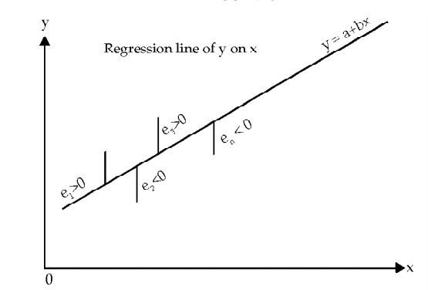
Let’s Understand what cost function(error function) is and how gradient descent is used to get a very accurate model.

Cost Function of Linear Regression

Alexander Mils on Unsplash
Cost Function is a function that measures the performance of a Machine Learning model for given data.
Cost Function is basically the calculation of the error between predicted values and expected values and presents it in the form of a single real number.
Many people gets confused between Cost Function and Loss Function,
Well to put this in simple terms Cost Function is the average of error of n-sample in the data and Loss Function is the error for individual data points.In other words,Loss Function is for one training example,Cost Function is the for the entire training set.
So,When it’s clear what cost function is Let’s move on.
The Cost Function of a linear Regression is taken to be Mean Squared Error.
some.People may also take Root Mean Square Error.Both are basically same,However adding a Root significantly reduces the value and makes it easy to read.We,take Square here so that we don’t get values in negative.
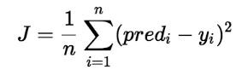
Here, n is the total number of data in the dataset.
You must be wondering where does the slope and intercept comes into play here!!
J = 1/n*sum(square(pred - y))Which, can also be written as :J = 1/n*sum(square(pred-(mx+b))) i.e, y = mx+b 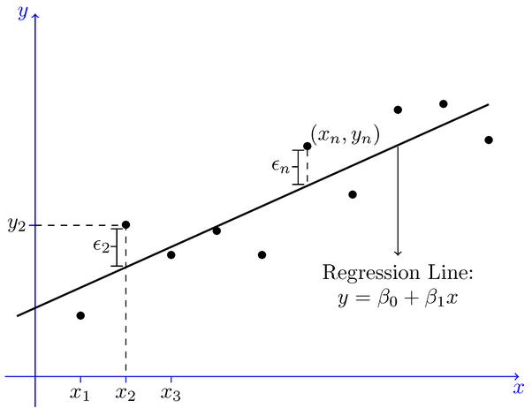
We want the Cost Function to be 0 or close to zero,which is the best possible outcome one can get.
And how do we acheive that?
Let’s Look at the gradient descent and how it helps improve the weights(m and b) to achieve the desired cost function.

Linear Regression with Gradient Descent

Daniel Frank on Unsplash
Gradient descent is an optimization algorithm used to find the values of parameters (coefficients) of a function that minimizes a cost function (cost).
To Read more about it and get a perfect understanting of Gradient Descent i suggest to read Jason Brownlee’s Blog.
To update m and b values in order to reduce Cost function (minimizing MSE value) and achieving the best fit line you can use the Gradient Descent. The idea is to start with random m and b values and then iteratively updating the values, reaching minimum cost.
Steps followed by the Gradient Descent to obtain lower cost function:
→ Initially,the values of m and b will be 0 and the learning rate(α) will be introduced to the function.
The value of learning rate(α) is taken very small,something between 0.01 or 0.0001.
→ Then the partial derivative is calculate for the cost function equation in terms of slope(m) and also derivatives are calculated with respect to the intercept(b).After Calculation the equation acheived will be.
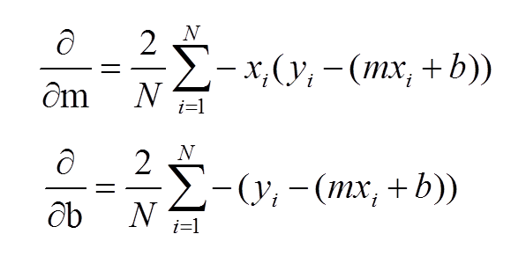
Guys familiar with Calculus will understand how the derivatives are taken.
If you don’t know calculus don’t worry just understand how this works and it will be more than enough to think intuitively what’s happening behind the scenes and those who want to know the process of the derivation check out this blog by sebastian raschka.
→ After the derivatives are calculated,The slope(m) and intercept(b) are updated with the help of the following equation.
m = m+α*derivative of m
b = b+α*derivative of b
derivative of m and b are calculated above and α is the learning rate.
You must be wondering why I added and not subtracted,Well if you observe the result of the derivative you will see that the result is in negative.So the equation turns out to be :
m = m — α*derivative of m
b = b — α*derivative of b
If you’ve gone through the Jason Brownlee’s Blog you might have understood the intuition behind the gradient descent and how it tries to reach the global optima(Lowest cost function value).
Why should we substract the weights(m and b)with the derivative?
Gradient gives us the direction of the steepest ascent of the loss function and the direction of steepest descent is opposite to the gradient and that is why we substract the gradient from the weights(m and b)
→ The process of updating the values of m and b continues until the cost function reaches the ideal value of 0 or close to 0.
The values of m and b now will be the optimum value to describe the best fit line.
I hope things above are making sense to you.So,Now let’s understand other important things related to the linear Regression.
Till now we have understood How the Slope(m) and Intercept(b) are calculated,what Cost Function is and How Gradient Descent algorithm helps get the ideal Cost Function Value with the help of Simple Linear Regression.
For Multiple Linear Regression everything happens exactly same just the formula changes from a simple equation to a bigger one as shown above.
Now to understand How Co-efficients are calculated in Multiple Linear Regression,please go to this link to get a brief idea about it, Although you won’t be performing it manually ,but, it’s always good to know what’s happening behind the scene.
Now Let’s Look at how to check the quality of the model.

Interpreting the results of Linear Regression:

National Cancer Institute on Unsplash
You have cleaned the data and passed it on to the model,Now the question arises,How do you know if your Linear Regression Model is Performing well?
For That we Use the Statsmodel Package in Python and After fitting the data we do a .Summary() on the model,which gives result as shown in the pic below.(P.S. — I used a pic from google images)
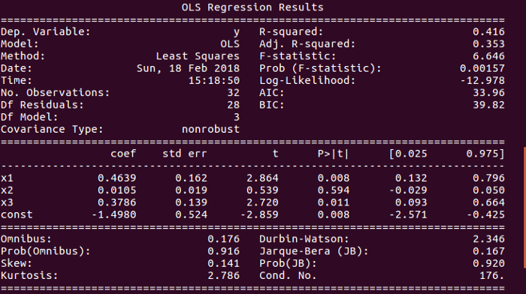
Now,If you Look at the Pic Carefully you will see a bunch of different Statistical test.
I Suppose you are familiar with R-Squared and Adjusted R-Squared shown on the top right of the image,If you don’t no worries read my blog about R-Squared and P-value.
Here we will see what the lower block of the image interprets.
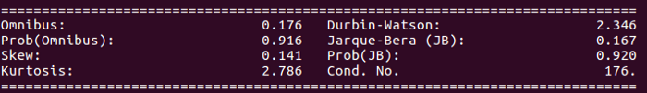
- Omnibus/Prob(Omnibus):It is statistical test that tests the skewness and Kurtosis of the residual.
A value of Omnibus close to 0 show the normalcy(normally distributed) of the residuals.
A value of Prob(Omnibus) close to 1 show the probability that the residuals are normally distributed.
- Skew: It is a measure of the symmetry of data,values closer to 0 indicates the residual distribution is normal.
- Kurtosis: It is a measure of whether the data are heavy-tailed or light-tailed relative to a normal distribution. That is, data sets with high kurtosis tend to have heavy tails, or outliers. Data sets with low kurtosis tend to have light tails, or lack of outliers.
Greater Kurtosis can be interpreted as a tighter clustering of residuals around zero, implying a better model with few outliers.
- Durbin-Watson:It is a statistical test to detect any auto-correlation at a lag 1 present in the residuals.
→ value of test is always between 0 and 4
→ IF value = 2 the there is no auto-correlation
→ IF value greater than(>) 2 then there is negative auto-correlation,which means that the positive error of one observation increases the chance of negative error of another observation and vice versa.
→ IF value less than(<) 2 the there is positive auto-correlation.
- Jarque-Bera/Prob(Jarque-Bera):It is a Statistical test which test a goodness of fit of whether the sample data has skewness and kurtosis matching the normal distribution.
Prob(Jarque-Bera) indicates normality of the residuals.
- Condition Number:This is a Statistical Test that measures the sensitivity of a function’s output as compared to its input.
When there is multicollinearity present , we can expect much higher fluctuations to small changes in the data,So the value of the test will be very high.
A lower value is expected,something below 30,or more specifically value closer to 1.
I hope this helped you understand the Linear Regression Algorithm and Most of the concepts related to it.
Coming up next Week,We will Understand the Logistic Regression.
HAPPY LEARNING!!!!!

